  Ghent, Belgium  Fact & Figures  - Over €532 million in annual research expenditure (2023)  - More than 150 European Research Council (ERC) grants awarded  - More than 8,000 peer-reviewed publications annually  - 90 spin-off companies and 1,273 patents (2011–2021)  - 11 faculties, 130 departments  - 50,000 students, with over 7,400 international students from more than 100 countries  - 1,543 professors and 1,731 postdoctoral researchers  - #83 in Times Higher Education World Rankings (2025)  - #30 in QS World University Rankings: Sustainability (2024)  - #90 in Academic Ranking of World Universities (2024)  Major Research Areas  - Life Sciences & Biotechnology  - Environmental Science & Sustainability  - Engineering & Materials Science  - Information and Communication Technology (ICT)  - Food and Agricultural Sciences  - Social Sciences & Humanities  - Health & Medical Sciences  - Veterinary Medicine |  | Ghent University

“Dare to Think” - Ghent University is an internationally renowned, open, pluralistic and socially engaged university in Belgium
- About Us
Ghent University (UGent), established in 1817, is one of Europe’s top public research universities, located in the historic and vibrant city of Ghent, Belgium. As a globally renowned institution, Ghent University consistently ranks among the top 100 universities worldwide and is celebrated for its dedication to academic excellence, pioneering scientific research, and societal impact. The university embraces a strong international outlook, promoting openness, inclusiveness, and sustainability as core values in both education and research.
We’re proud to say we are the first European university in South Korea, with Ghent University Global Campus.
Today, Ghent University hosts over 50,000 students, including more than 7,400 international students from over 100 countries, supported by a dedicated academic staff of 1,500 professors and 1,700+ postdoctoral researchers. The university comprises 11 faculties and more than 130 departments, offering an expansive and interdisciplinary academic ecosystem that spans sciences, (bioscience) engineering, life sciences and medicine, veterinary medicine, social sciences, arts, law, and humanities.
With a research budget exceeding €530 million annually, Ghent University is at the forefront of scientific innovation. It is home to numerous world-renowned research centers and spin-offs, boasting significant (academic) achievements in biotechnology, environmental science, engineering, ICT, food and agricultural sciences, health, and social sciences. The university plays a leading role in the European Research Area and has received over 150 European Research Council (ERC) grants, demonstrating its scientific leadership and impact.

- Why Choose Us?
•Interdisciplinary Research Environment: Use Ghent University’s comprehensive research environment to collaborate across various disciplines, encouraging innovative research that addresses global challenges.
•State-of-the-Art Facilities: Access cutting-edge laboratories and research centers equipped with the latest technology to support your research endeavors.
•Global Network: Benefit from Ghent University’s extensive international partnerships, including its Global Campus in South Korea, facilitating cross-cultural academic exchange.
•Supportive Community: Join a welcoming and inclusive community that values diversity and provides comprehensive support for international researchers.
Contact & Further Information  Website: www.ugent.be/en  Social Media: @ugent  Contact: EU-team@UGent.be  For more details and to begin your application journey:  •MSCA Postdoctoral Fellowships (MSCA PF)  •Support Services: Master lass for MSCA-PF applicants with Ghent University as their Host Institution  Embark on a transformative research experience at Ghent University. Join a community where innovation thrives, and your potential knows no bounds. |  | 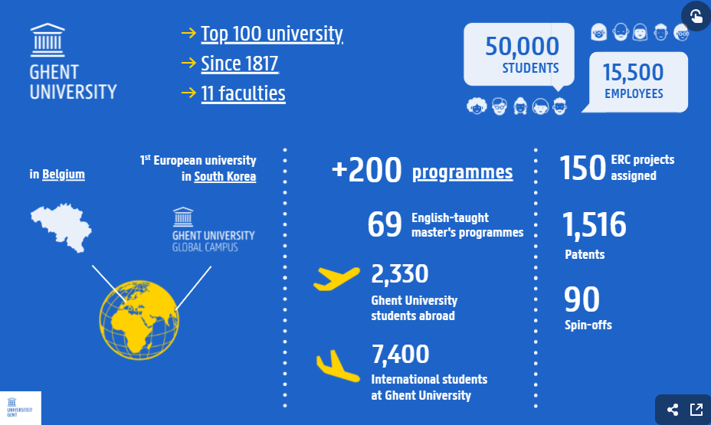
- Our Support for Applicants
Ghent University is committed to supporting MSCA Postdoctoral Fellowship applicants throughout the application process:
•Master Class: Participate in a free online Master Class focusing on proposal preparation, eligibility criteria, and funding opportunities.
•Personalized Guidance: Receive assistance from Ghent University’s dedicated EU Team, including proposal guidance, administrative support, and legal advice
•Supervisor Matching: Get help in identifying and connecting with potential Ghent University supervisors aligned with your research interests.
•Resource Access: Make use of Ghent University’s extensive range of writing tips, in-depth guidance, and recorded sessions to strengthen your application.

